**CAT(check and track) your internet usage**

Design and Planning

Rev. 1.0 2018-5-1- initial version

**<System Architecture>**

**MVC**



**Model**

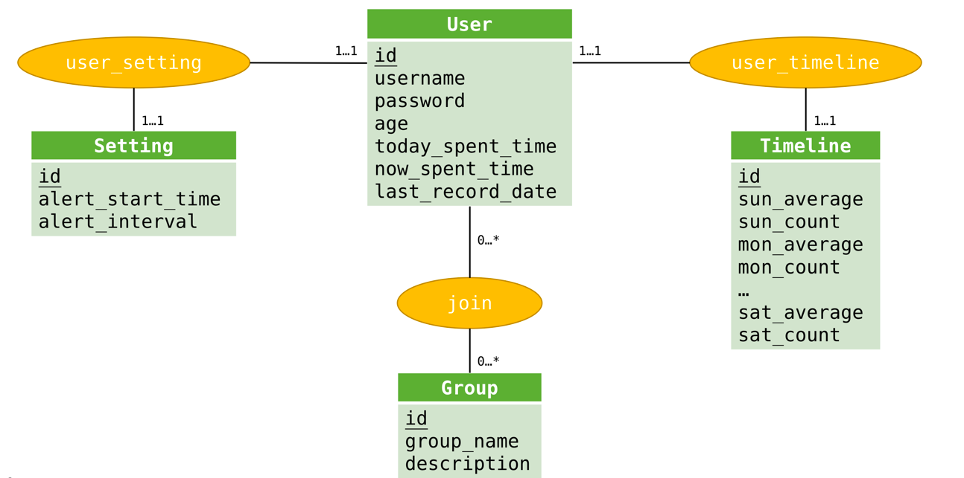

Above is Entity-Relationship diagram for model design. Green rectangle stands for entity set, yellow oval stands for relationship set, and numbers next to line represent mapping cardinality constraints(min..max). Entity attributes are listed inside entity rectangle.

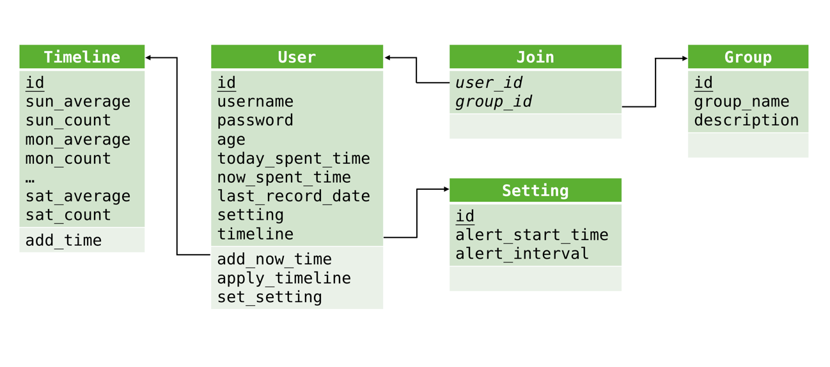

Above is relation schema diagram based on Entity-Relationship diagram, and it will be structure of Django models. Green rectangle stands for relation schema, schema attributes are listed inside. And underlined attribute indicates primary key.

**View**

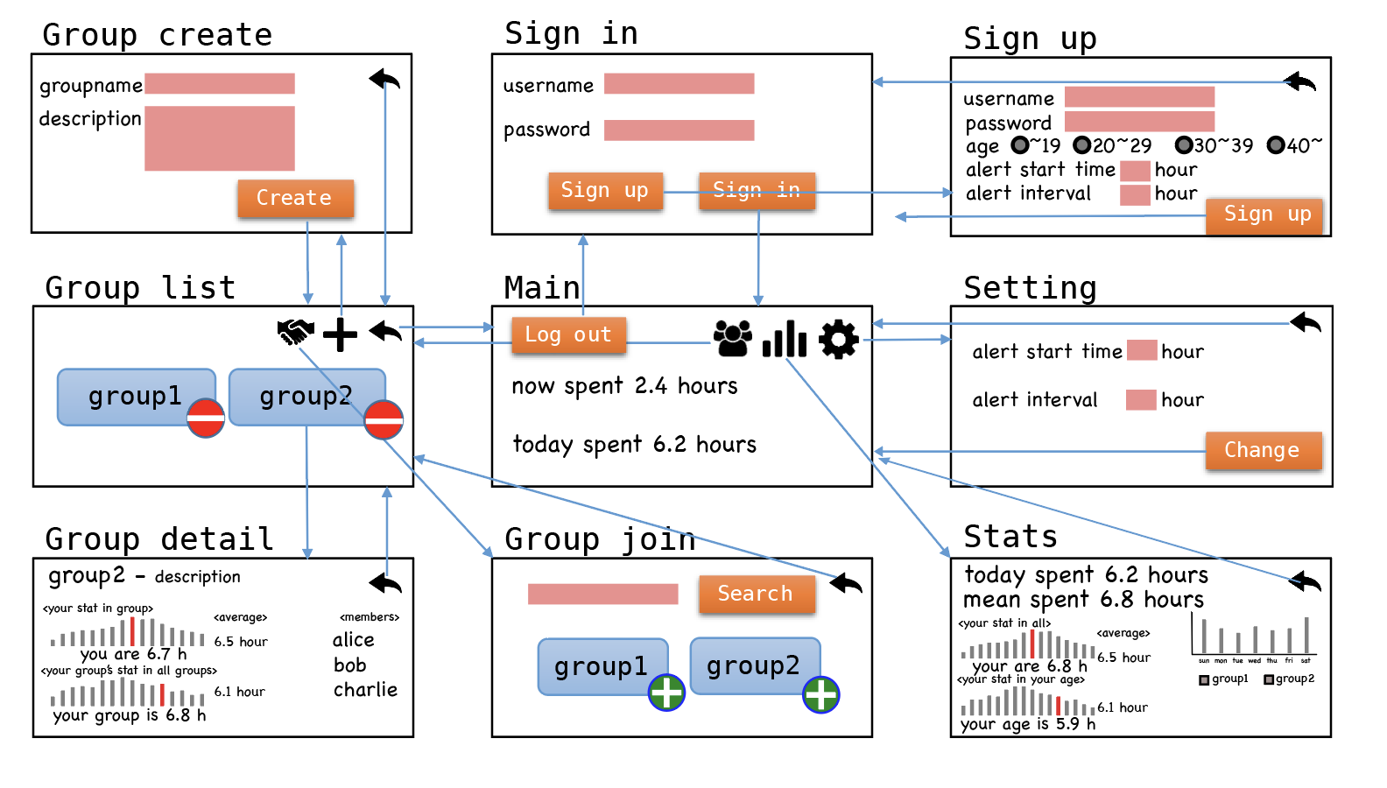

Above is user interface for view design. The functionality for each page are described below.

1. Sign In page (/sign_in)

-User can either sign in or go to sign up page if user is not yet registered to the website

-Get ‘username’, ‘password’ as user inputs

1. Sign Up page (/sign_up)

-Sign up a new user

-Get ‘username’, ‘password’, ‘age’ as user inputs, set up alert start time and alert interval for the user

1. Main page (/main)

-Show total time of today’s internet usage and total time of this session

(Session is from the time the user logs in to the website and until the time the user closes the website. All sessions during a day will add up to today’s total internet usage time and will be updated to the main page when the user logs in to the website at different date.)

1. Group List page (/group)

-Show list of groups that the user joined

-Buttons to move to Group Join page or Group Create page

1. Group Detail page (/group/:id)

-Show the details of the specific group; how many people joined the group, users’ list, chart showing the status of group’s internet usage time among total users, and chart showing the status of the user’s internet usage time among the group members.

1. Group Join page (/group/join)

-Show total list of all groups(group name and number of group members)

-Search for specific group by getting group name from user

1. Group Create page (/group/create)

-Create new group by getting group name and group description from user

1. Statistics page (/stats)

-Show statistics of the user’s internet usage (internet usage time of today, mean of spent time, and histogram showing average spent time by days)

-Show statistics of the total users’ internet usage (histogram showing total users internet usage time, internet usage time of users within the same age group, internet usage time of groups’ the user belongs to)

1. Settings page (/settings)

-User can change alert start time, and alert interval

**Controller**

Left side is view part(frontend) and right side is model part(backend), and ‘Controller’ part in the middle shows http requests with data.

**Controller**

**Model**

**View**

Sign Up

User

Nickname, password, age

Setting

Alert start time, alert interval

User

Sign In

User object

Username.id

User

Main

Today spent time

Now spent time

Group

Group List

Group object

Group

Group Join

Search Query

User Object

Group

Group Create

Group name

Group description

Setting

Setting

Alert start time

Alert interval

User object

Stats

Group

Group object

Timeline

Timeline object

<**Design Details>**

**Frontend Design**



**Frontend Relations**



**Frontend Algorithms**

1. ngOnInit

-Check whether the user is logged in by calling backend api, and redirect to main page if user is not signed in.

1. Sign In

-Call backend sign-in api, and return the result

1. Sign Up

-Make a new user. If username is already used, alert the user to use other username. If sign up is successful, redirect to sign-in page

1. Main page

-Show now spent time and today spend time on the page by getting data from backend(Time will be fetched every minute).

1. Group List page

-Show groups by getting Group objects from backend

1. Group Detail page

-Show specific groups’ data by getting filtered Group objects from backend

1. Group Join page

-If user types certain query, it sends the query to backend and fetch that data and apply the data to the page

-When user moves the mouse pointer to certain group, the page will show description of that certain group using ‘react-cursor-position’

1. Group Create page

-Make a new group. If group name is already used, alert the user to use other username.

1. Statistics page

-Takes in from the backend parsed numbers, and make histogram using these numbers by using D3 to compute sizes and positions

1. Settings page

- Get data from backend and show. If user wants to change data, update the data.

**Backend Design**

In the backend design, we use models which have been discussed in MVC architecture section

**RESTful API**

|  |  |  |  |  |  |
| --- | --- | --- | --- | --- | --- |
| **Model** | **API** | **GET** | **POST** | **PUT** | **DELETE** |
| **User** | /signup | X | Create new user | X | X |
| /signin | X | Log in | X | X |
| /signout | Log out | X | X | X |
| /user/:id | Get specific user | X | X | X |
| **Group** | /group | Get group list | Create new group | X | X |
| /group/:id | Get specific group | X | X | Delete specific group |
| **Timeline** | /timeline | Get timeline list | Create new timeline | X | X |
| /timeline/:id | Get specific timeline | X | Update time | X |
| **Setting** | /setting | X | Create new setting | X | X |
| /setting/:id | Get specific setting | X | Update alert timings | X |
| **Join** | /join | Get join list | Create new join | X | X |
| /join/:id | X | X | X | Delete join |

**<Implementation Plan>**



**<Testing Plan>**

We will test every modules and components. After passing each test, next module or component will be started. Before starting a next sprint, we expect to over 80% of the code coverage.

* Jest
* Unit test module (built in to the Python standard library)